**Report for Wahoo Dataset**

**Imdb_Table:**

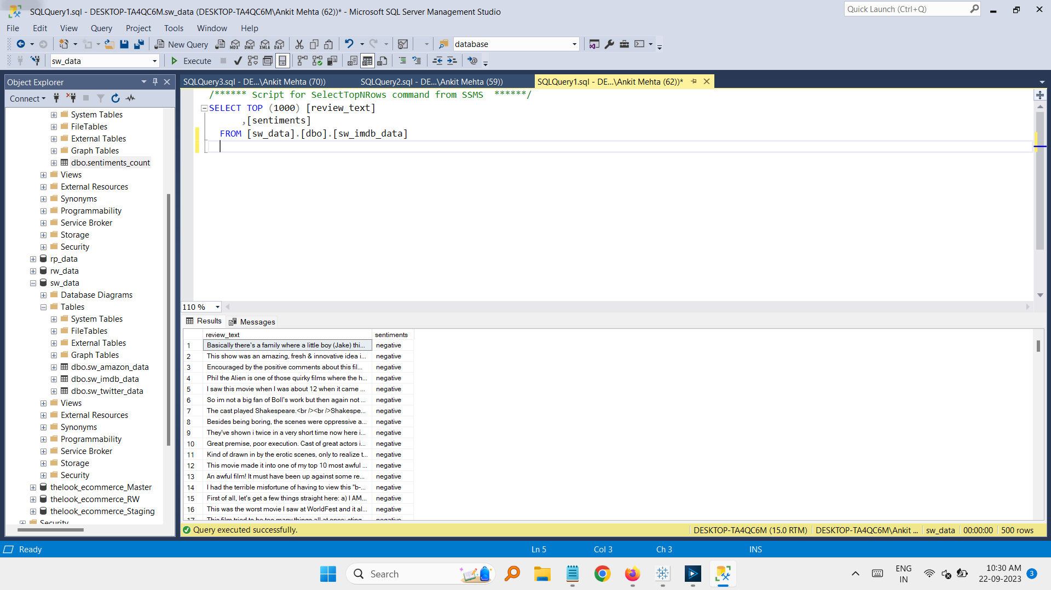

Sql table view for IMDB table.

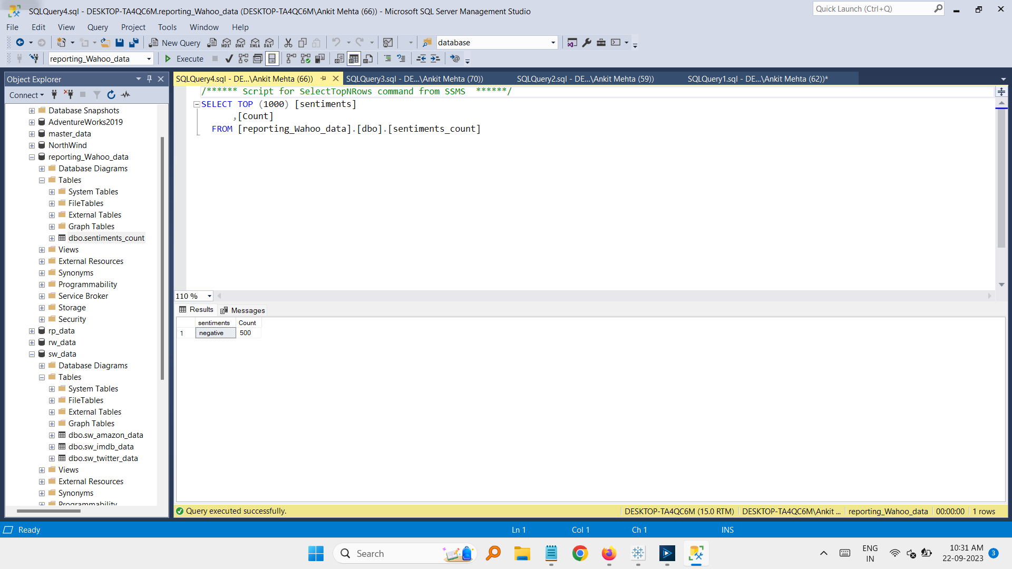

For given dataset all users given ‘Negative’ comments for the movies.

Total number of comments are: 500

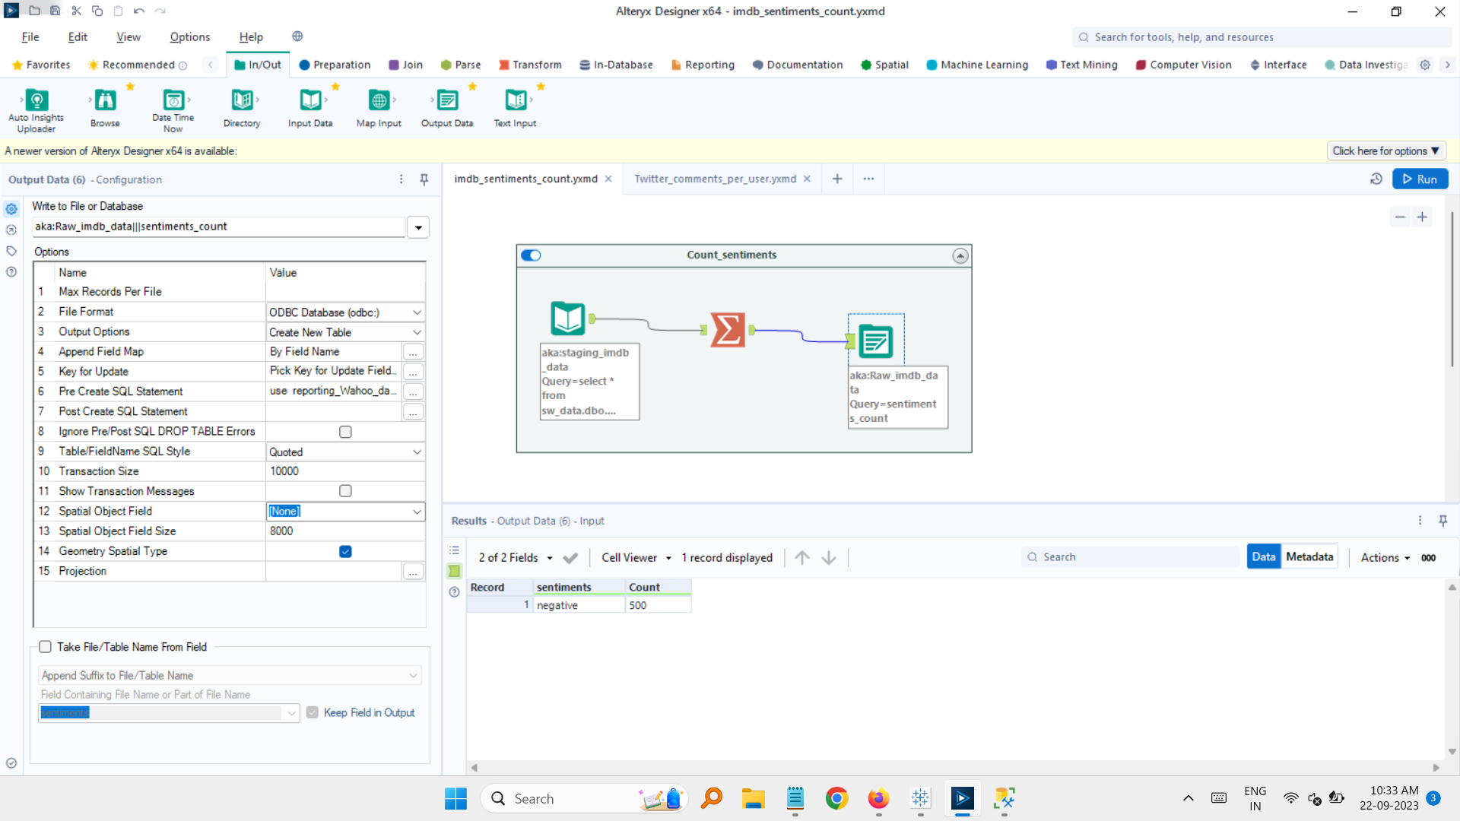

Alteryx workflow for counting and ETL processing for this table.

**Twitter_table:**

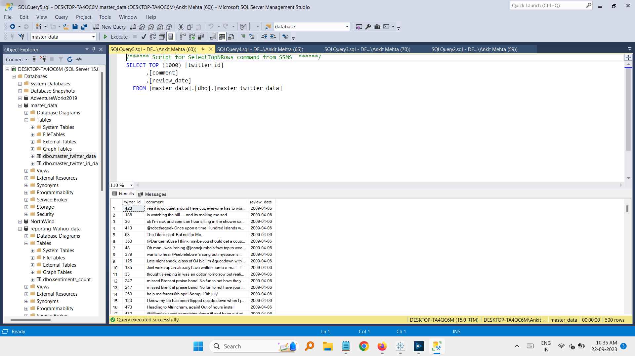

Sql view for Twitter Table.

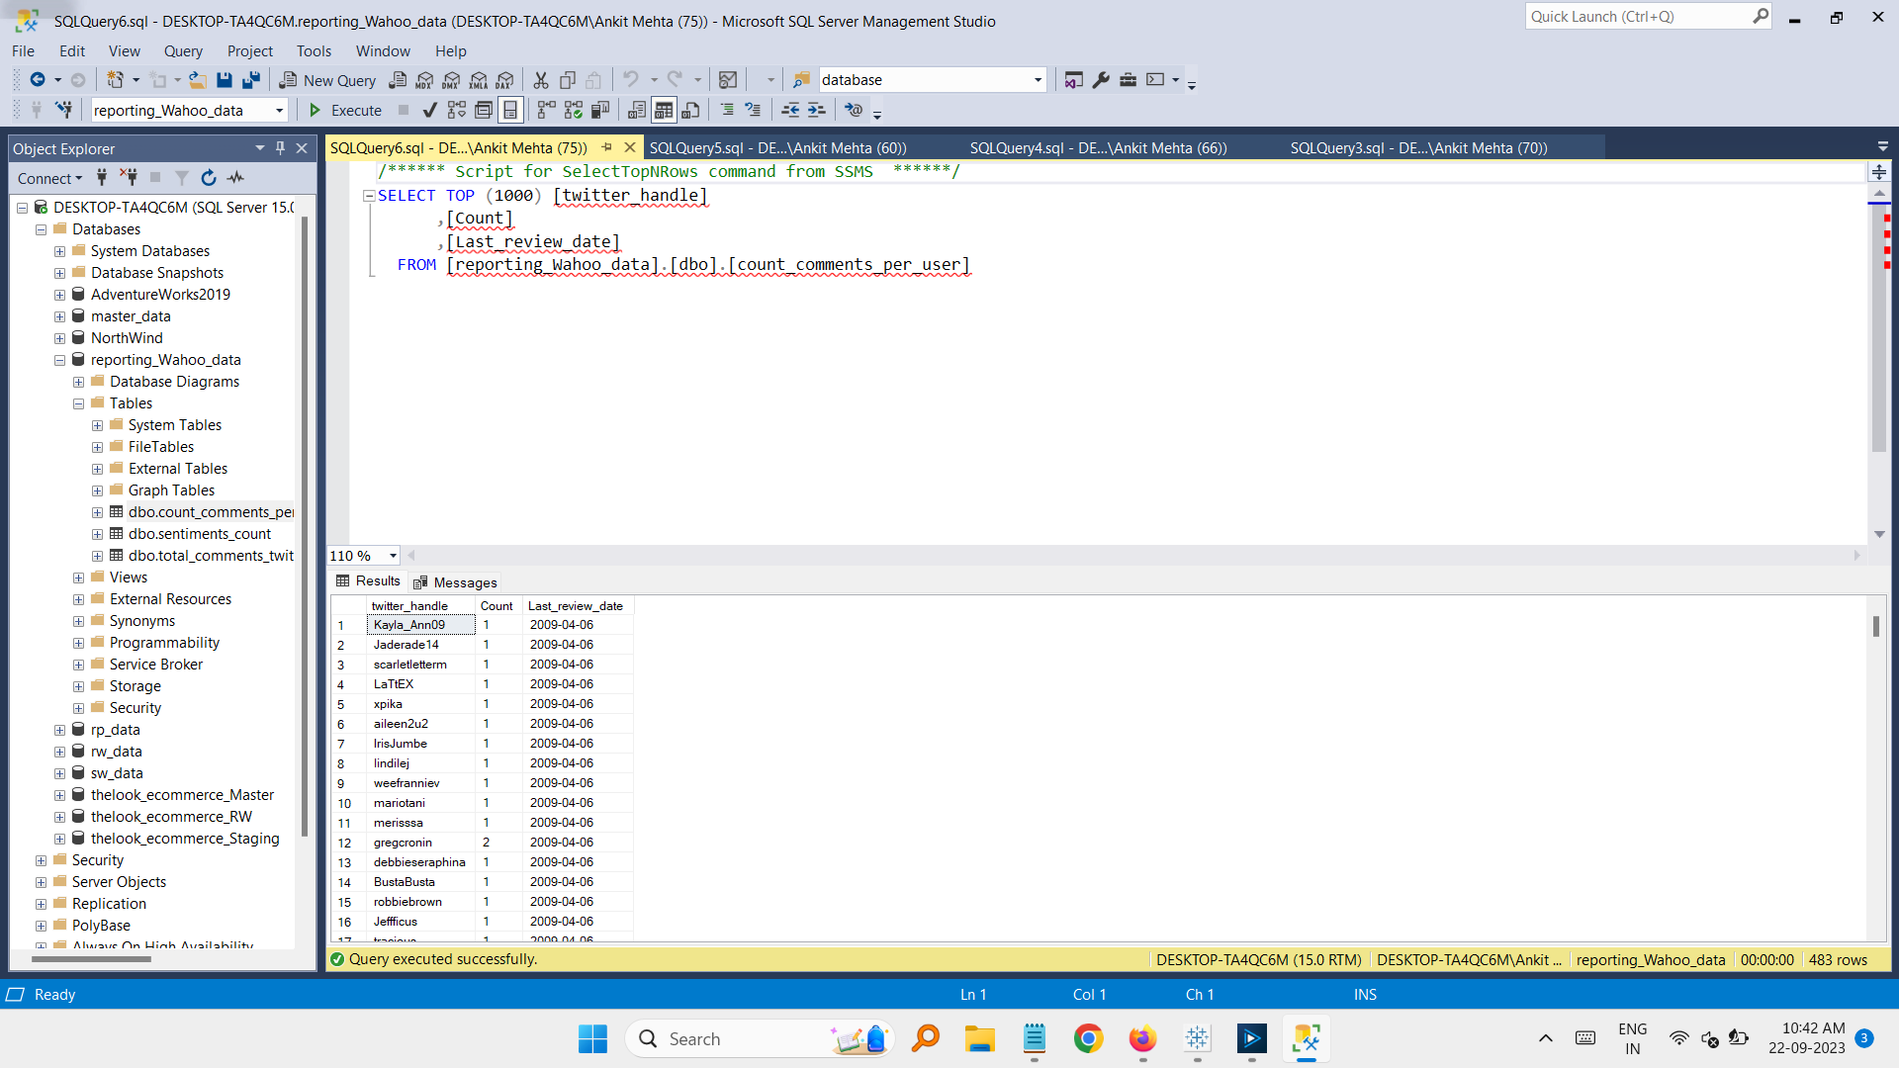

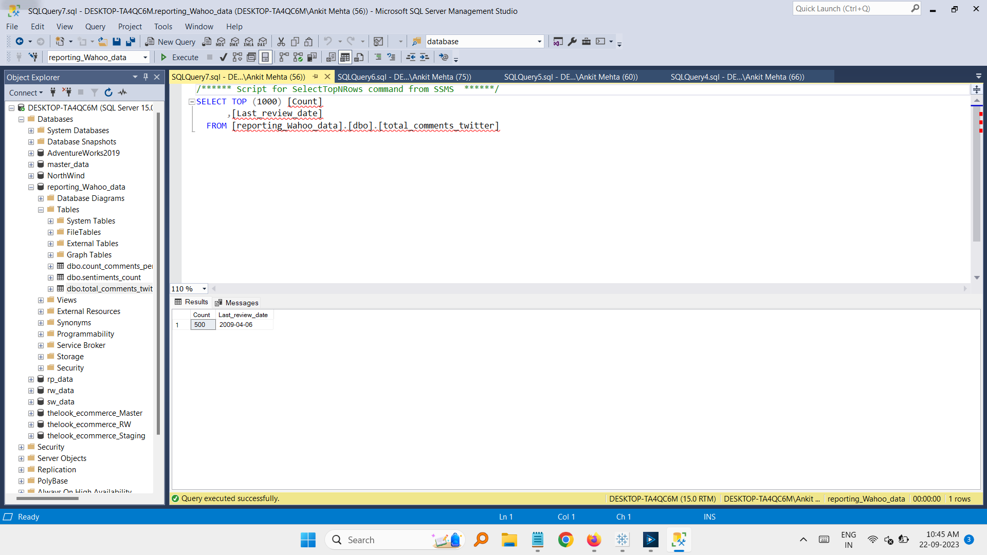

For given dataset:

1. Twitter comments per user were done on same day which is: 2009-04-06
2. Total comments were: 500

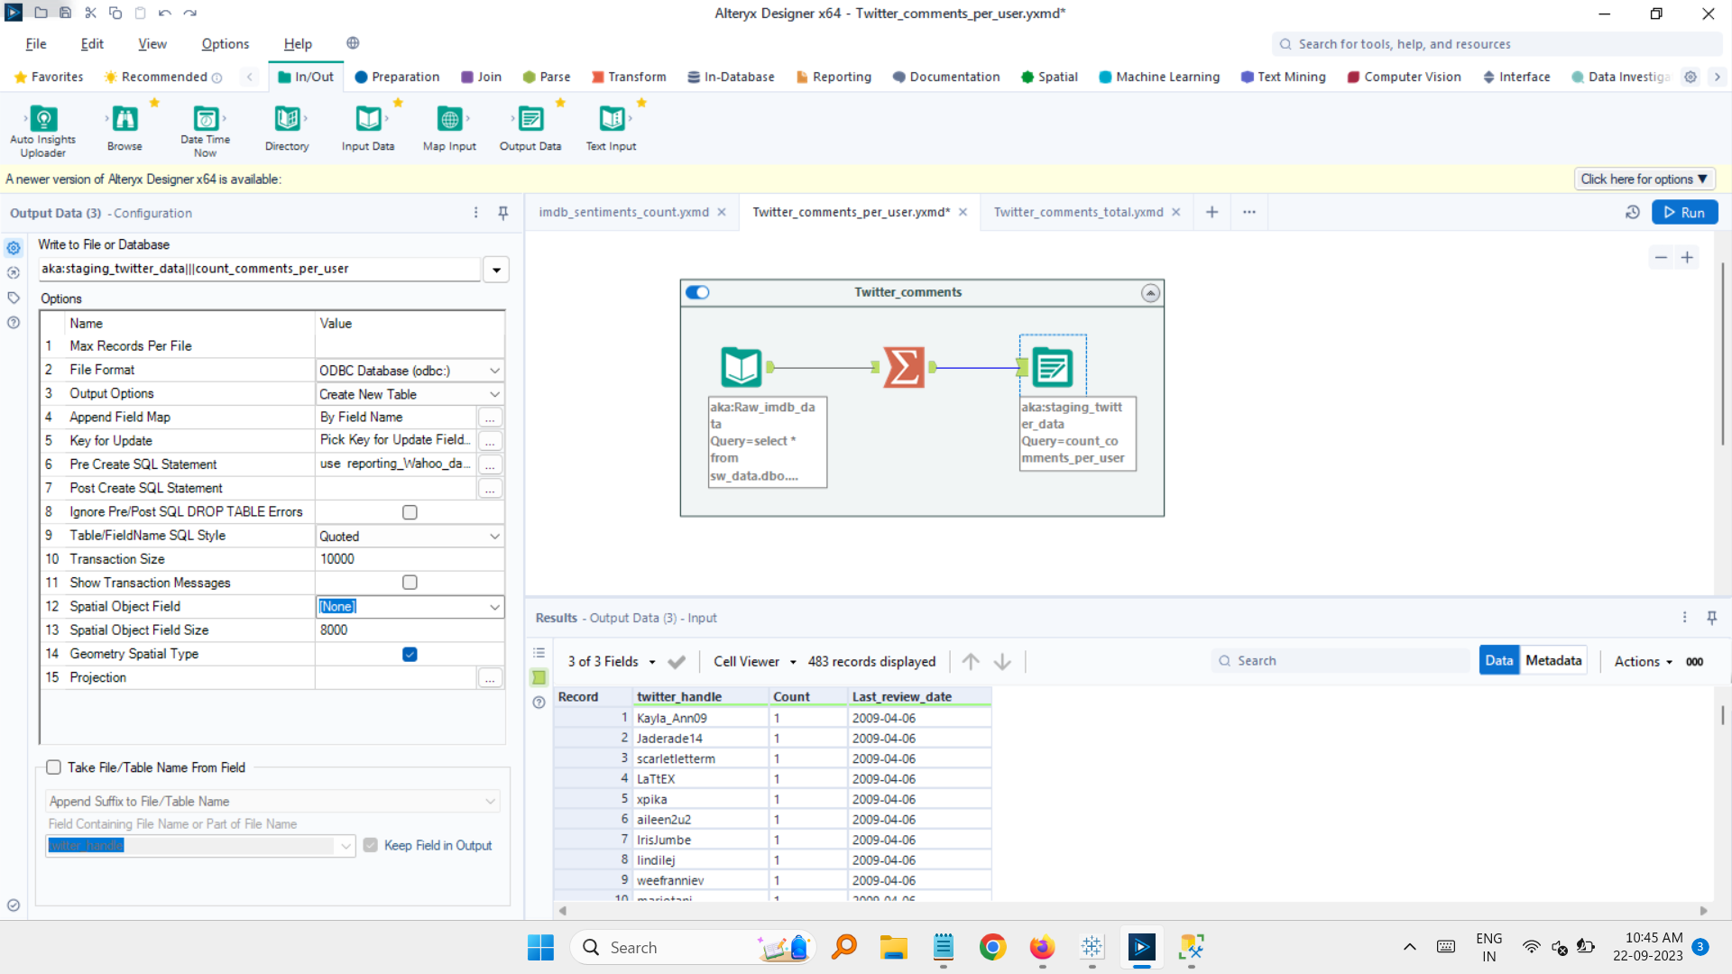

Alteryx workflow for counting comments per user and ETL processing for this table.

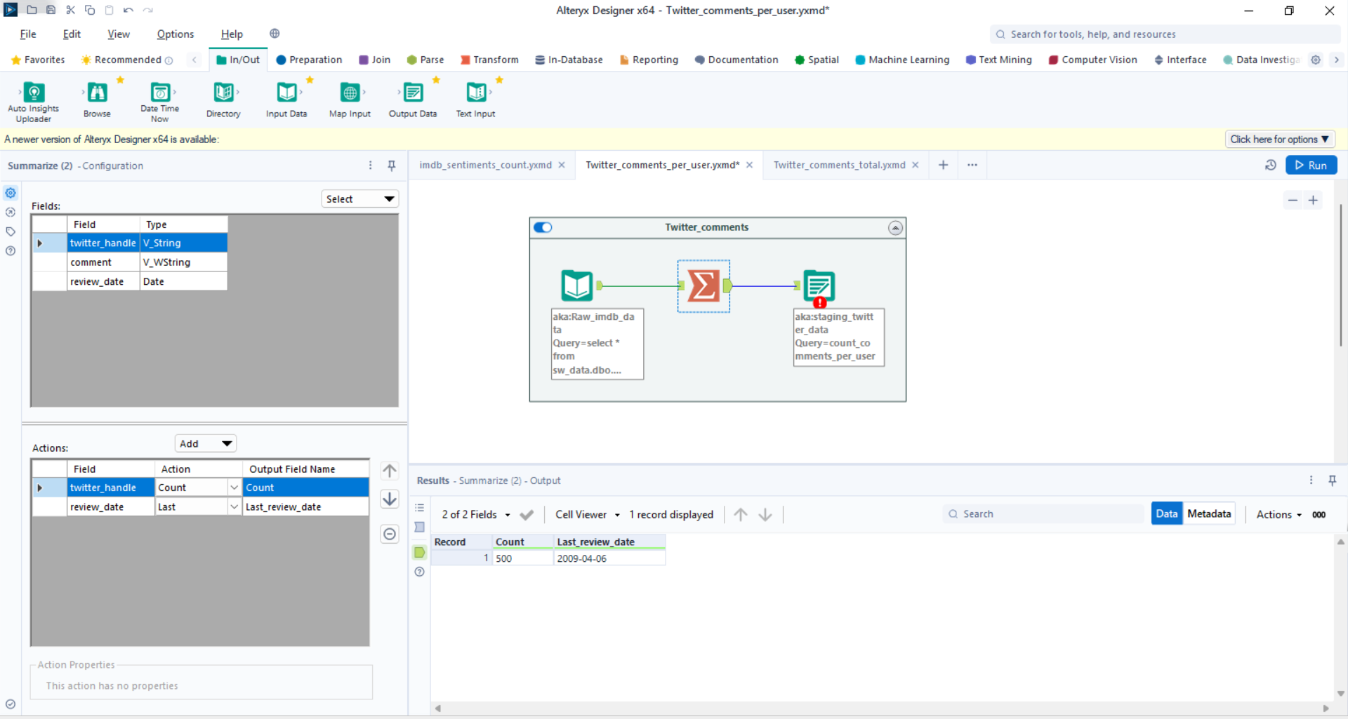

Alteryx workflow for counting Total comments by users and ETL processing for this table.

**Amazon_Table:**

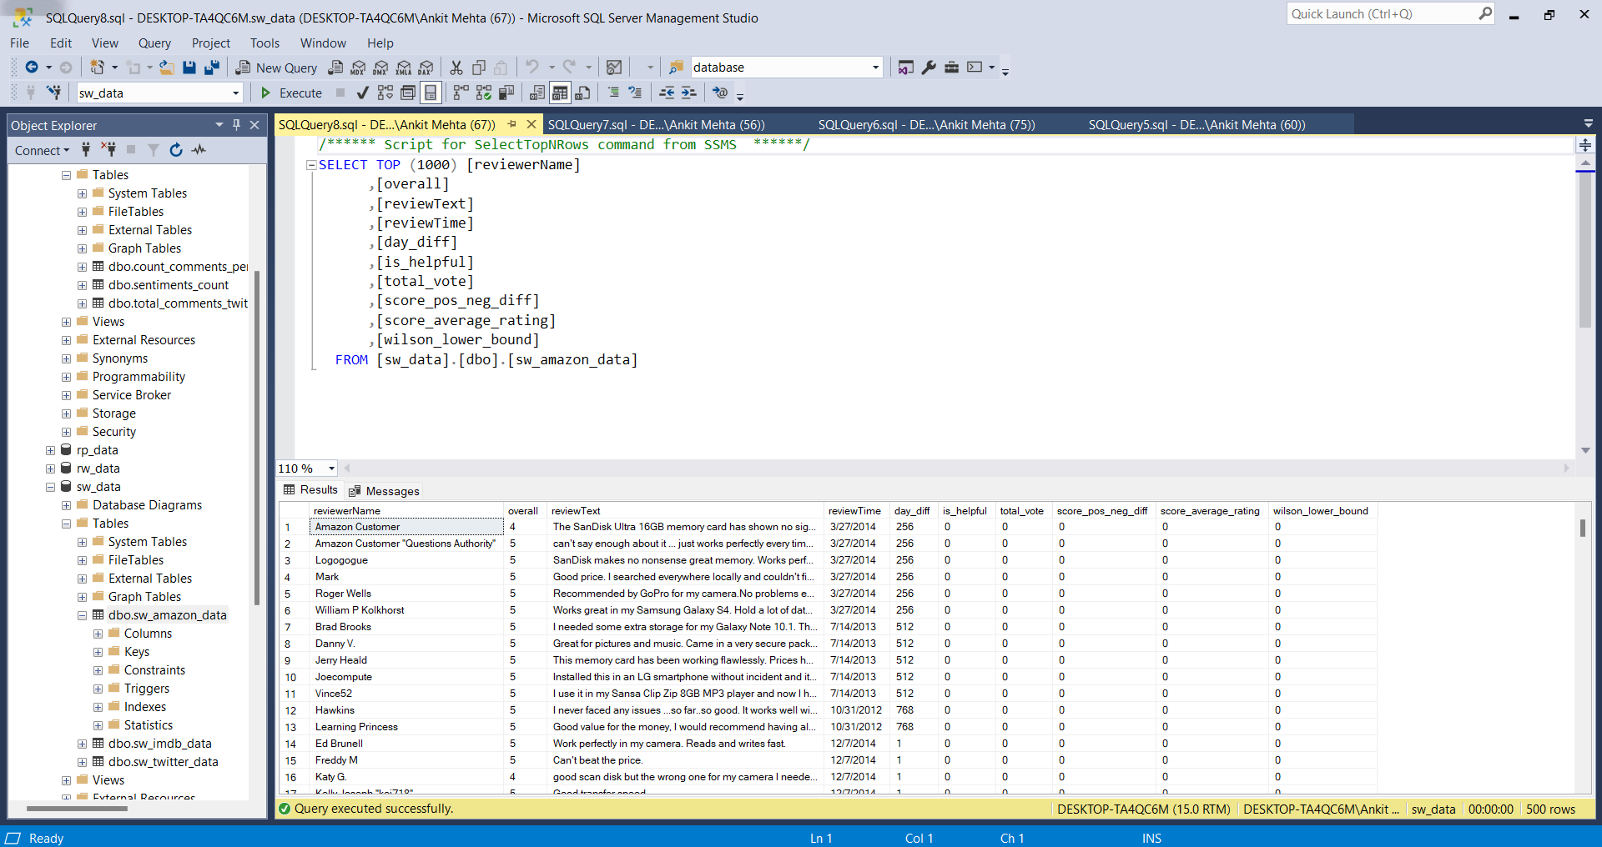

Sql View of Amazon table.

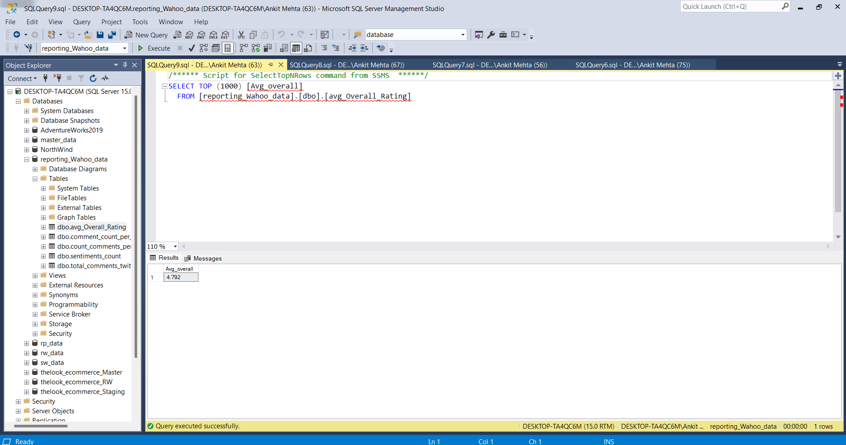

Average of Overall Rating: 4.792

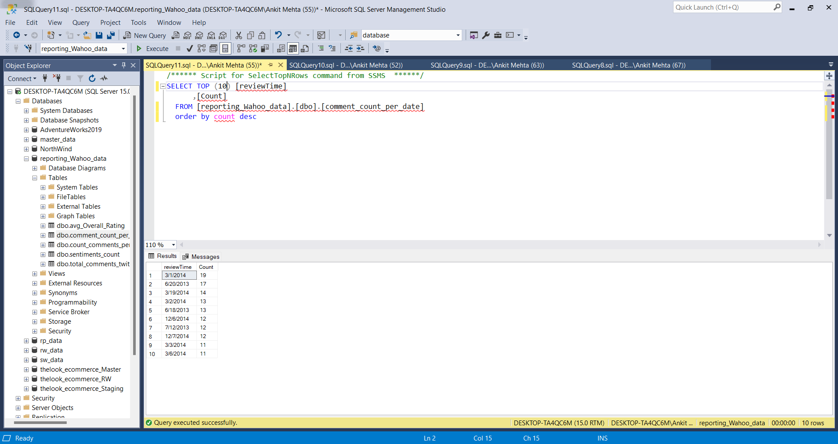

Total count of comments per ReviewDate

Top 10 counts:

reviewTime Count

3/1/2014 19

6/20/2013 17

3/19/2014 14

3/2/2014 13

6/18/2013 13

12/6/2014 12

7/12/2013 12

12/7/2014 12

3/3/2014 11

3/6/2014 11

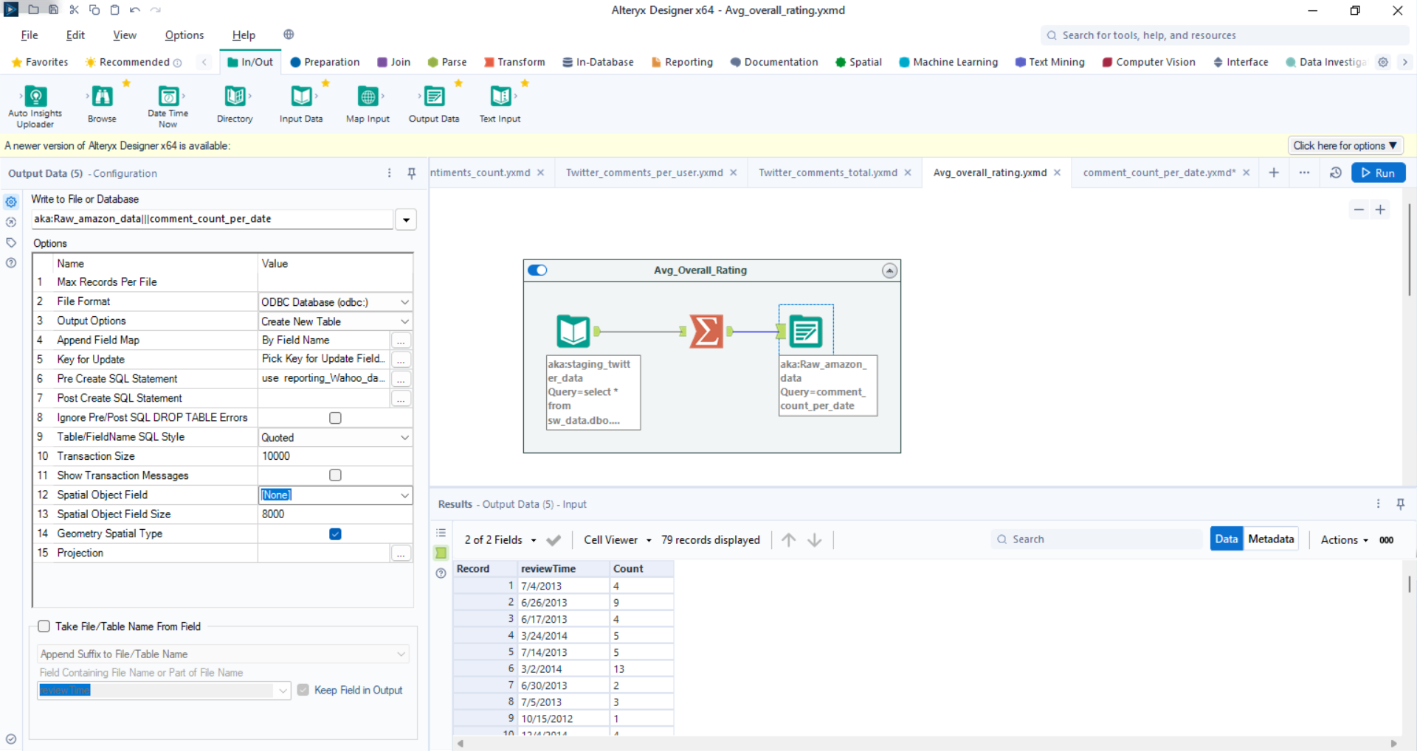

Alteryx workflow for counting Total comments by users per date and ETL processing for this table.

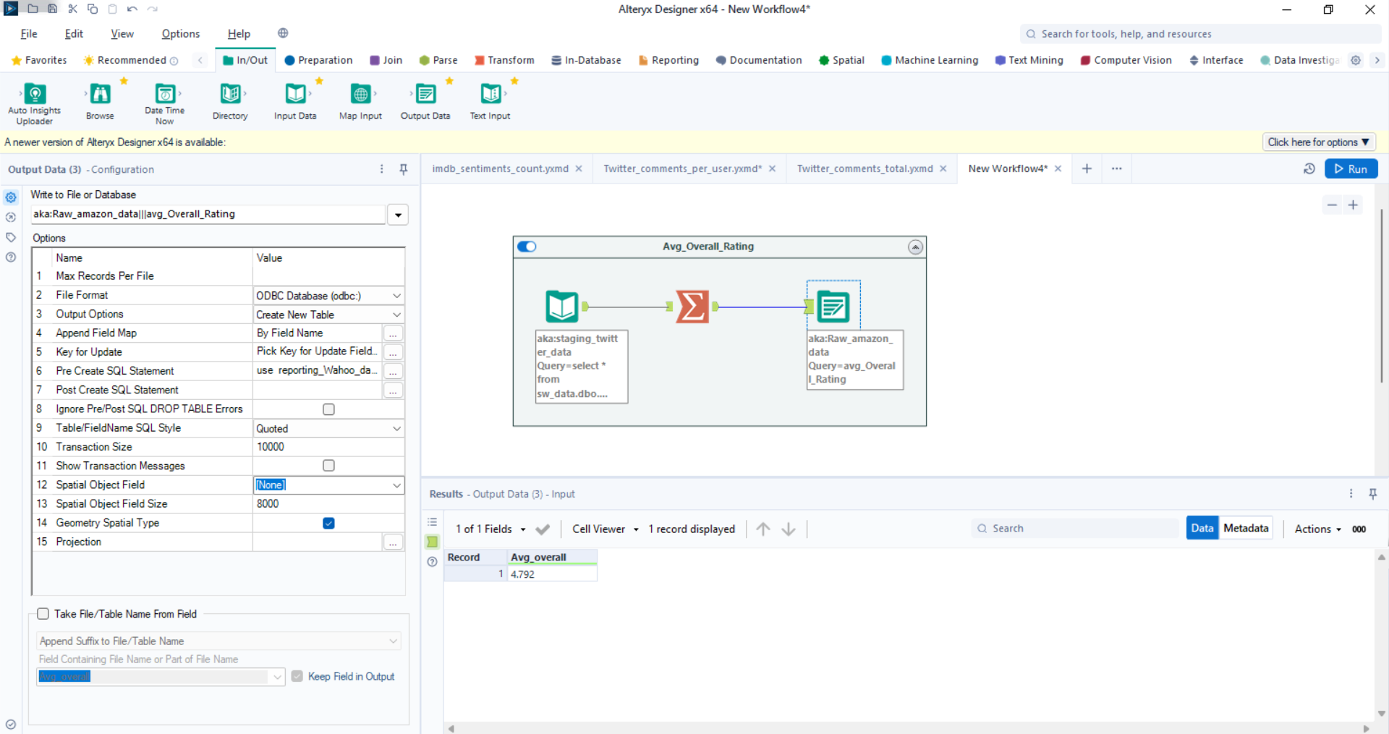

Alteryx workflow for counting Average of Overall Rating and ETL processing for this table.

**Conclusion:**

In this report, I've provided information about three tables: IMDB_Table, Twitter_Table, and Amazon_Table, as well as the Alteryx workflows associated with each of them. These workflows serve a variety of purposes, including tasks like comment counting, calculating averages, and conducting ETL (Extract, Transform, Load) operations on the data.